

12 PHYSICS

THE STANDARD MODEL

The Standard Model is based on the theories of quantum mechanics and special relativity and the assumption that interactions between particles are caused by exchange particles called gauge bosons.

Physicists have been able to classify the particles they have discovered into three groups - leptons, gauge bosons and hadrons, according to their interactions.

The diagram below illustrates how the known particles are classified under the Standard Model.

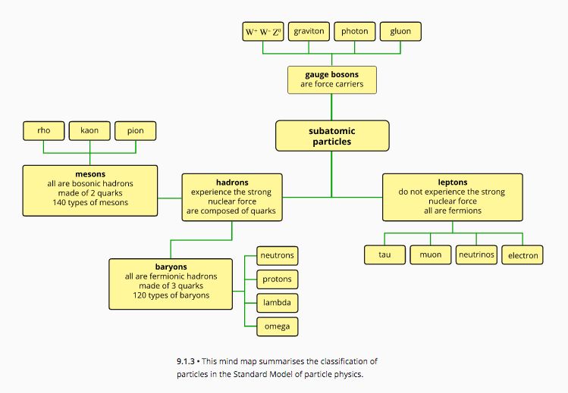

Fundamental Forces and The Gauge Bosons

There are four forces that can act on particles and govern their behaviour. The fundamental assumption in the Standard Model is that forces arise through the exchange of particles called gauge bosons (or just bosons).

Bosons are often called force-carrying, force-mediating or exchange particles.

The table below gives a summary of the nature of these particles, their strength and the range over which they can exert a force.

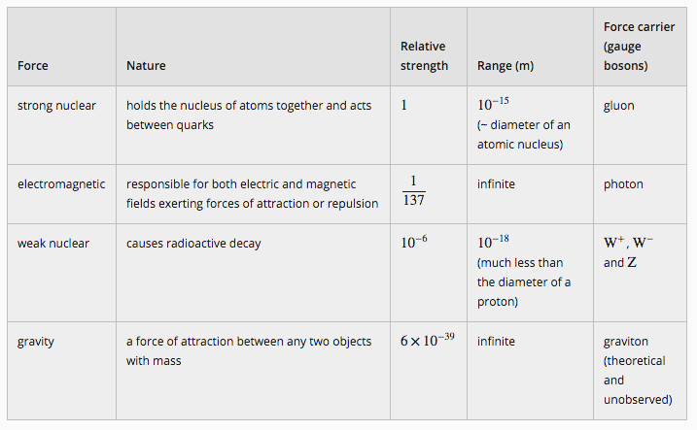

Example

The diagram below represents an electron approaching another electron. Each electron emits a photon that is absorbed by the other. This causes each electron to experience a force of repulsion, and the photon is responsible for the electromagnetic force acting on the two electrons.

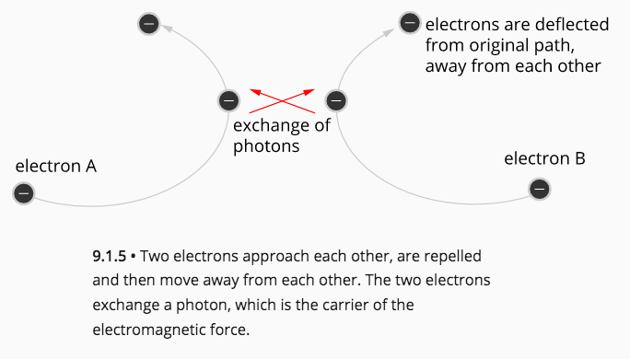
MATTER

Matter is not as simple as protons, neutrons and electrons. These are not the smallest particles - Physicists have discovered a large number of smaller particles that make up matter.

For the purpose of this course, only a simplified view will be used.

Matter And Anti-Matter

For each particle that exists, there is an anti-matter particle to match.

e.g. An electron has its anti-matter particle - the positron. The positron has many of the
same properties including mass, but it has a positive charge as opposed to the negative
charge of the electron. Other features of the positron are also opposite to the electron’s
properties.

Once the positron was discovered, other anti-matter particles began to be uncovered, such as the anti-proton and the anti-neutron.

Anti-matter is extremely rare on Earth and is greatly outnumbered in the universe by regular matter, which is a puzzle.

When normal matter interacts with its anti-matter equivalent, the two particles will convert all of their mass into energy (E = mc²) in a process called annihilation.

Example
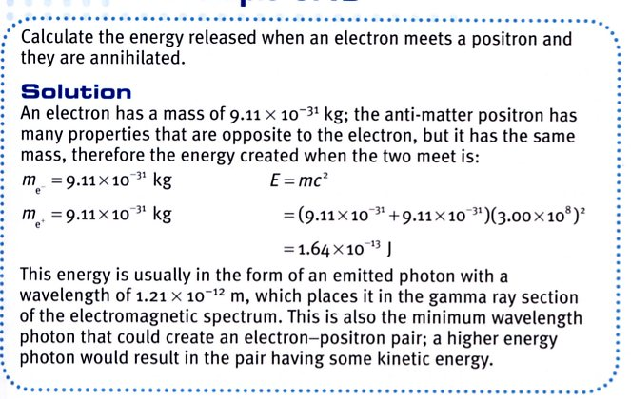

Classifying New Particles

• Bosons

This group of particles mediate the strong nuclear, electromagnetic and weak forces.

They include the gluons, photons and the W and Z particles.

• Leptons

This group of particles interact by exchanging W and Z bosons, which mediate the weak
nuclear force.

Leptons that carry a charge can also interact by exchanging photons, which
mediate the electromagnetic force, but they do not interact via the strong force carriers.

These particles include the electron, muon and tau particles, as well as their corresponding
neutrinos and the anti-matter opposites of these six particles.

• Hadrons

This group of particles is further categorised into two groups is, the baryons and the mesons,
based on a property called baryon number (B)

The common feature of the hadrons is that they all interact by exchanging gluons, which are
the particles that mediate the strong nuclear force.

Hadrons that carry a charge can also interact by exchanging photons, but the effect of the
gluons far outweighs any other force mediating particle.

• Mesons

These are particles that have been assigned a baryon number of zero.

In this group are many particles and their anti-particles.

e.g. pion (π⁺), anti-pion (π–) and pi-zero (π⁰), the kaon (K⁺) and anti-kaon (K–),
and the eta (η⁰).

• Baryons

These are particles that have been assigned a baryon number of 1 for normal matter or -1 for anti-matter.

In this group are the familiar proton (p⁺) and anti-proton (p–), neutron (n) and anti-neutron
(), along with hundreds of other particles and their anti-particles.

e.g. the lambda-zero (Λ⁰) and anti-lambda-zero (), sigma-plus (Σ⁺), sigmazero (Σ⁰) a and sigma-minus (Σ–), the xi-zero (Ξ⁰) and omega-minus (Ω–).

As far as physicists know, all six leptons are considered to be fundamental particles as there appears to be no internal structure to them and their size appears to be unmeasurable.

Hadrons on the other hand appear to have an internal structure, indicating that they are actually made of smaller particles. These smaller particles must then be considered as the fundamental particles in nature.

These smaller particles are called quarks.

The six different types of quarks are referred to as the six flavours of quarks - up (u), down (d), strange (s), charmed (c), bottom (b) and top (t).

The last four quark names also apply to new quantum numbers and their conservation laws, called strangeness (S), charm (c), bottomness (b) and topness (t).

Quarks have their antimatter opposites called anti-quarks that have the opposite sign for all of
their quantum numbers.

Quarks have properties of baryon number, spin and charge, which must add together to give the total baryon number, spin and charge of the hadrons they combine to make.

Quarks also have another property called colour charge, which is similar to electric charge, and distinguishes between two quarks of the same flavour, but with different spin. The three colours of quarks are red, green and blue and the colours for the anti-quarks are anti-red (cyan), anti-green (magenta) and anti-blue (yellow).

Quarks must combine so that their colour charge property adds to equal white.

e.g. red + green + blue = white
red + cyan = white
green + magenta = white
blue + yellow = white

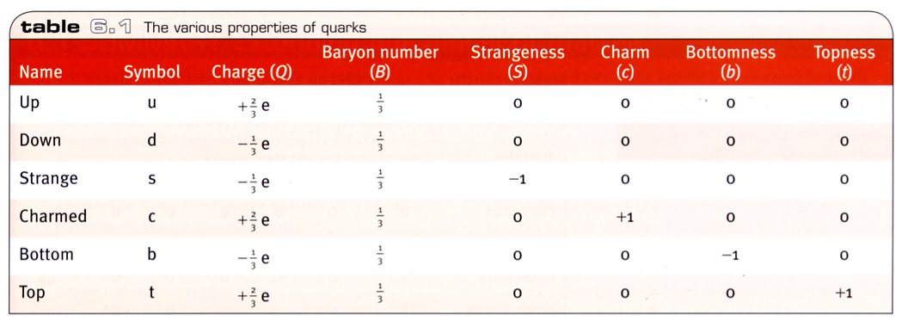

Fundamental Particles

The Standard Model says that all particles of matter are comprised of one or more of the 12 fundamental or elementary particles.

Being a fundamental particle means that it is not comprised of other smaller particles.

All these particles are called fermions and are divided into two groups of six particles called quarks (blue) and leptons (green).

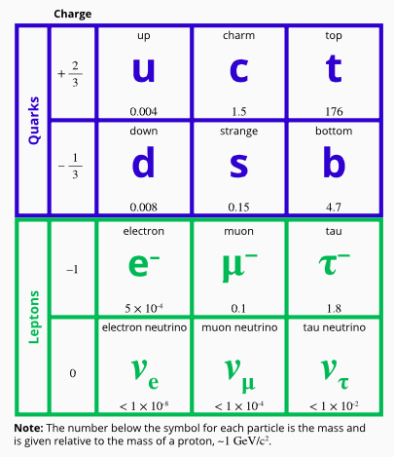

All fermions (quarks and leptons) obey Pauli's exclusion principle. This states that no two particles can occupy the same quantum state at the same time.

e.g. No two electrons can be in the same shell or orbital around an atom and have the same energy.

Fermions also have the same property, called spin angular momentum, abbreviated to just 'spin'.

All fundamental fermions have a spin of +1/2.

All quarks experience the strong nuclear force and this separates them from the leptons, as they do not.

Quarks also have non-integer (fractional) charges, unlike leptons, which have charges of -1, 1 or 0.

All fermions that carry a charge can interact via the electromagnetic force. Since neutrinos have zero charge, they obviously do not experience this force.

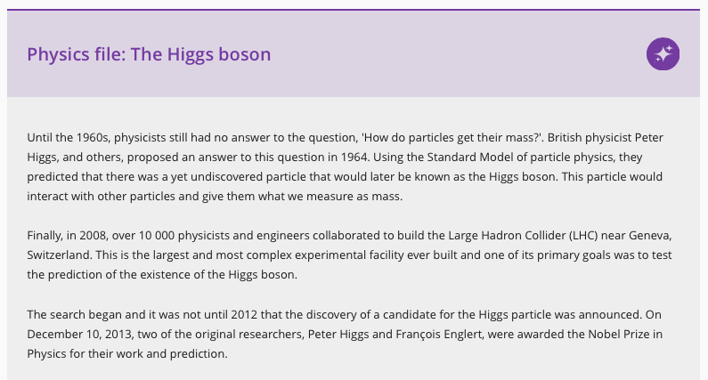

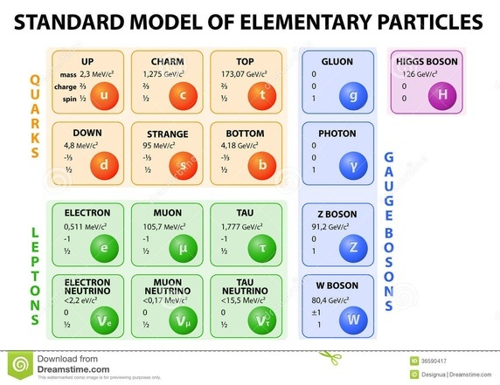

How To Make A Baryon

Baryons, which include the proton and neutron, consist of three quarks.

e.g. Proton - made up of two up quarks and a down quark (uud).

Total charge = +1 (the charge on a proton).

Neutron - made up of two down quarks and an up quark (ddu).

Total charge = 0

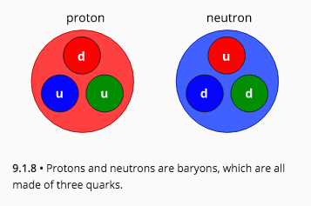

The following table summarises the baryons and their quarks.

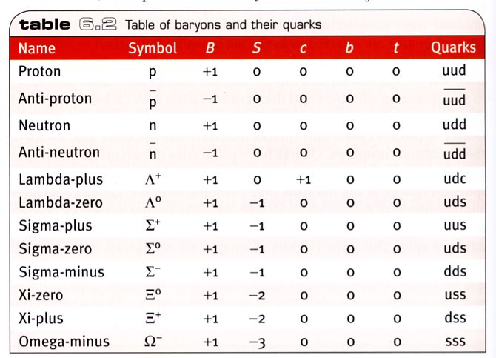

How To Make A Meson

Mesons consist of a quark and an anti-quark pair.

e.g. The pion-plus (π⁺) consists of an up quark and an anti-down quark ().

Total charge = +1

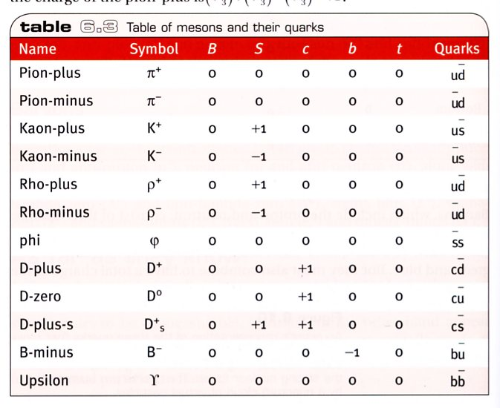

Strong Nuclear Force And The Colour Charge

According to the theory of quantum chromodynamics (QCD), the force that binds the quarks together in a hadron is called the colour force and it acts between the colour charge of the quarks.

The strong nuclear force between nucleons (or between any hadrons) is therefore a result of the colour force between the quarks within each of the hadrons.

e.g. The attraction between one proton and another, within a nucleus, is a result of the attraction between the quarks contained within each proton.

This leads to the gluon particles that are exchanged in the strong nuclear force being the same particles that exchange the colour force.

Particle Characteristics

The following tables show the various properties of the common leptons, mesons and baryons.

Note

Photons are not listed in the table - they are field particles and are involved in interactions between particles.

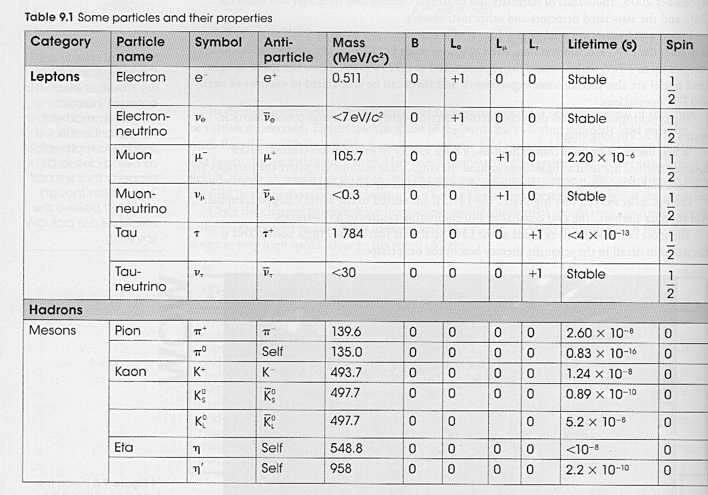

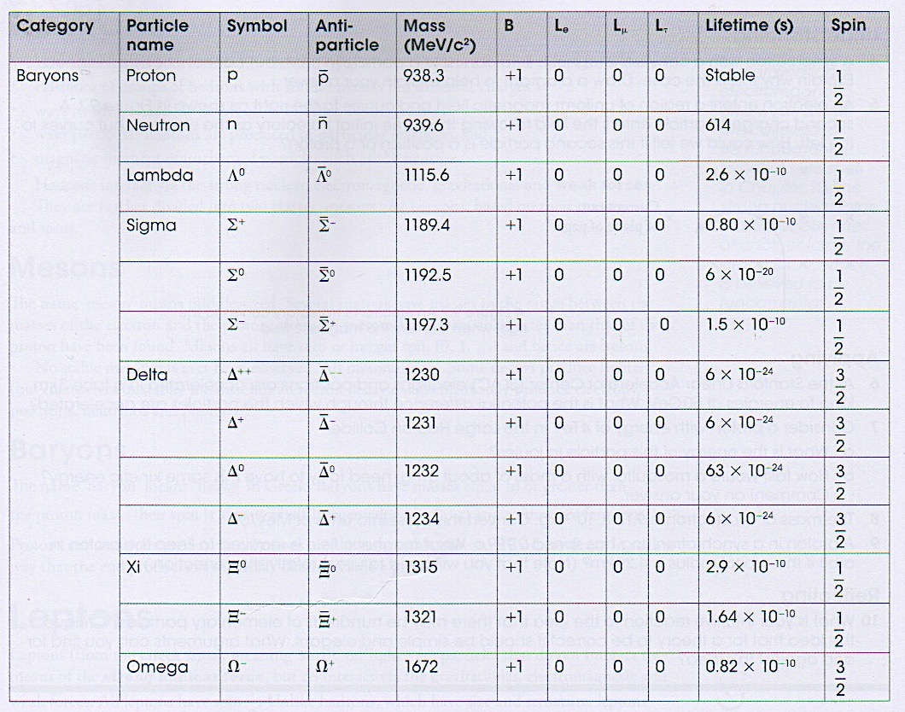
Summary

Hadrons

• Made up of three quarks.
• Interact via the strong nuclear, electromagnetic, gravitational and weak forces.
• Divided into mesons and baryons

Mesons

• Have integer spins (0, 1, 2, ...).
• Are bosons.
• No stable meson exists - they all decay.
• Meson decay produces electrons, positrons, neutrinos and photons.

Baryons

• Mass equal or greater than a proton.
• Have half-integer spins (1/2, 3/2).
• Protons and neutrons are baryons - protons are the only stable ones.

Leptons

• Don't interact via the strong nuclear force - only the other three.
• All have spin 1/2.
• Have no internal structure and are point-like.

Field particles

• The four fundamental forces are mediated by a field particle or exchange particle.

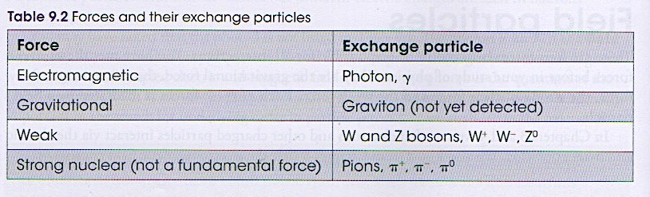

Conservation of Charge and Quantum Numbers

The quantum number for charge is conserved in particle decays.

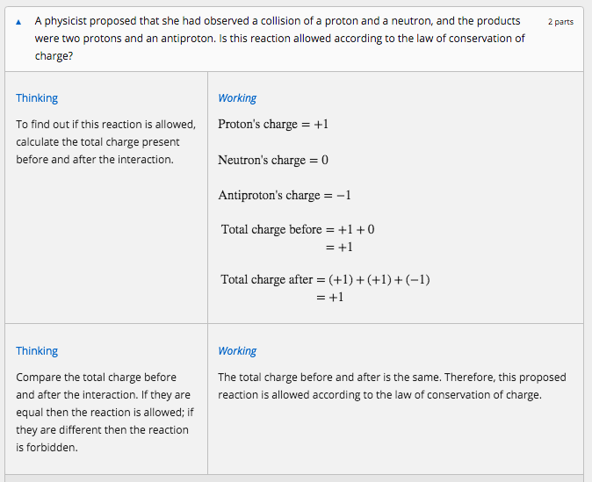

Conservation of Baryon Number

Baryons are all composite particles containing combinations of three quarks.

e.g. Protons and neutrons.

All baryons are given a quantum number - B = +1.

For antibaryons - B = −1.

For all of other particles involved in the interaction or decay - B = 0.

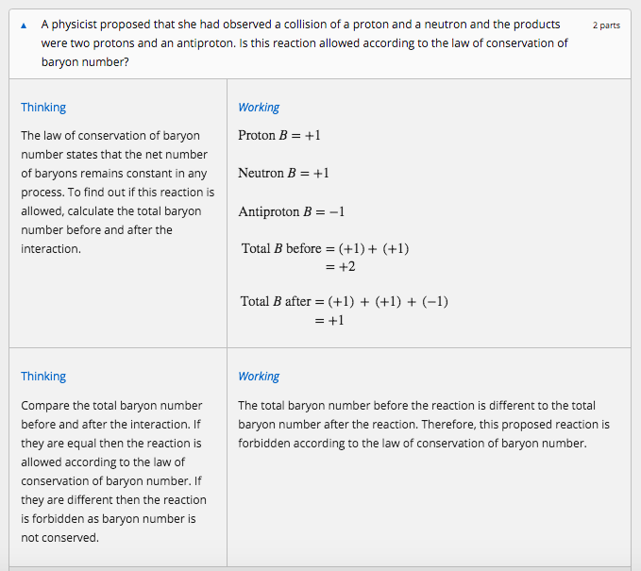

Conservation of Lepton Number

Leptons are the fundamental particles shown below.

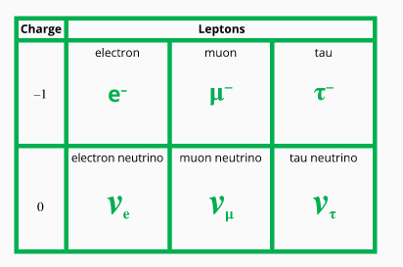

Lepton number, L, is a quantum number with value of +1 for leptons, −1 for antileptons and 0 for other particles.

There are actually three types of lepton numbers: one type for the electron and the electron neutrino, L_{e}; one type for the muon and the muon neutrino, L_{μ}; and one type for the tau and the tau neutrino, L_{τ}.

Each of these three lepton numbers must be considered and conserved independently. Both must be conserved for the reaction to be allowed.
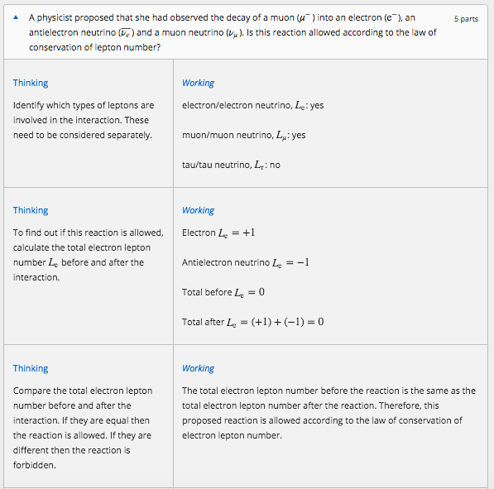
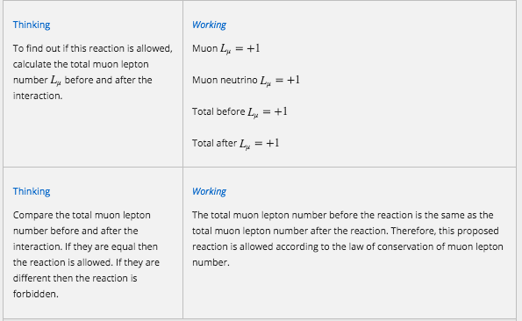

INTERACTIONS BETWEEN PARTICLES

Interactions between particles that produce some change and are observed by a particle detector are commonly known as events.

Those interactions that result in the formation of new particles are sometimes referred to as reactions.

Interactions can involve attractive or repulsive forces, decay or annihilation.

Examples

An example of a repulsive interaction involving the electromagnetic force would be the scattering of one electron by another.

This example is illustrated below using a diagram called a Feynman diagram.

It shows two electrons approach each other (on the horizontal axis) over time (the vertical axis) and exchange a photon.

This causes each electron to be repelled and therefore change direction.

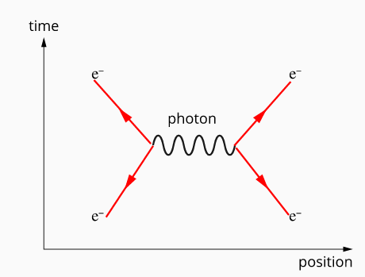

An example of a decay is the decay of a neutron into a proton.

This involves the weak nuclear force and is brought about by the conversion of a down quark in the neutron into an up quark.

This requires the emission of a W− boson, which decays into an antielectron neutrino and an electron.

This is commonly known as a beta-minus radioactive decay.

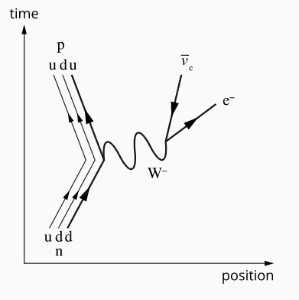

Note

It is important to note that the directions of the arrows in these diagrams do not indicate the direction a particle travels.

e.g. An antiparticle moves backwards in time.

Particles are represented by straight lines - the direction of the arrow represents the direction of time.

For antiparticles - the direction is reversed.

Wiggly lines represent massless exchange particles such as photons.

ASTRONOMY

Distances in Space

The only way the astronomers who followed Galileo could measure the distance to the stars was to look for parallax in their positions as the Earth moved around the Sun.

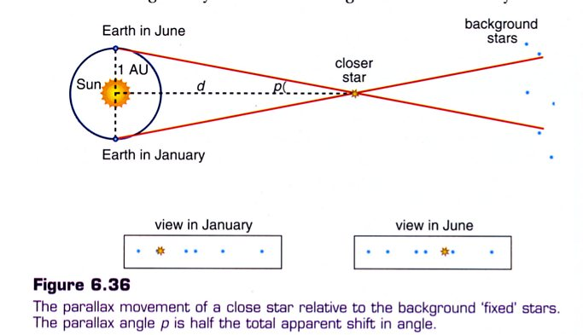

As the Earth moves around its orbit the closer star should appear to move in relation to those further away.

This method of measuring the distance to stars is known as stellar parallax. It leads to a natural unit for the distance of stars, the parsec.

The parsec (abbreviation pc) is the distance to a star that shows a parallax angle of 1.0 arc second.

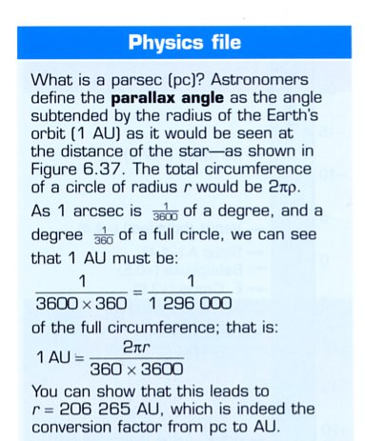

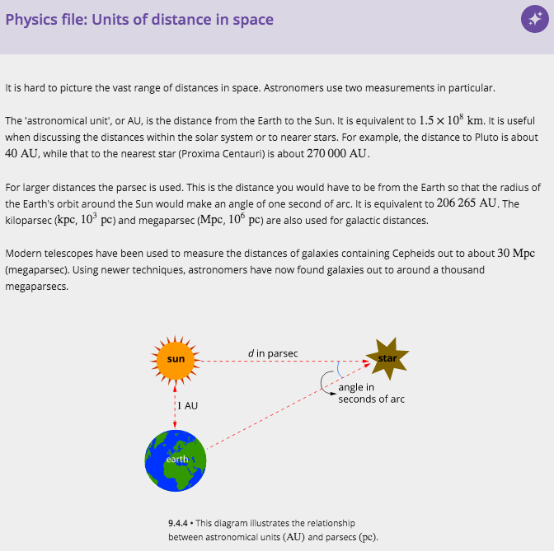

There is a simple relationship between a star's distance and its parallax angle:

where d = distance in parsecs
p = parallax angle in arcseconds.

Note

1.00 parsec = 3.26 light years
Limitations of Distance Measurement Using Stellar Parallax

Parallax angles of less than 0.01 arcsec are very difficult to measure from Earth because of the effects of the Earth's atmosphere. This limits Earth-based telescopes to measuring the distances to stars about 1/0.01 or 100 parsecs away.

Space-based telescopes can get accuracy to 0.001, which has increased the number of stars whose distance could be measured with this method. However, most stars even in our own galaxy are much further away than 1000 parsecs, since the Milky Way is about 30,000 parsecs across.

Example

A star has a parallax angle p of 0.723 arseconds. What is the distance to the star in parsecs and light years?

More Distant Stars

Cepheid variable stars and supernovae can be used to measure larger distances such as the distances between galaxies.

MODELS OF THE UNIVERSE

Aristotle (ancient Greece) - Earth in centre of universe.

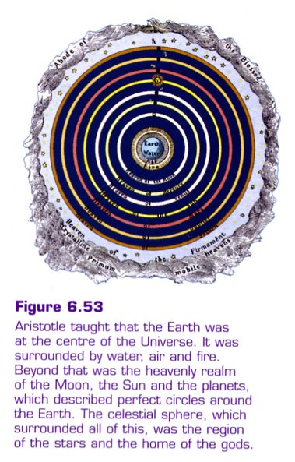

Ptolemy (200 BC) - Earth in centre; planets moved in circles around a large circle.

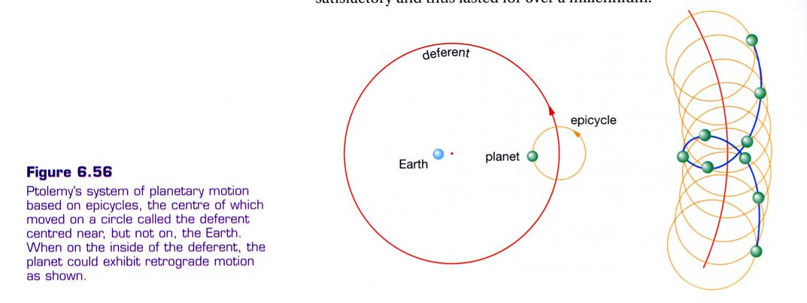

Copernicus (16th century) - Sun in centre, Earth and other planets circle it.

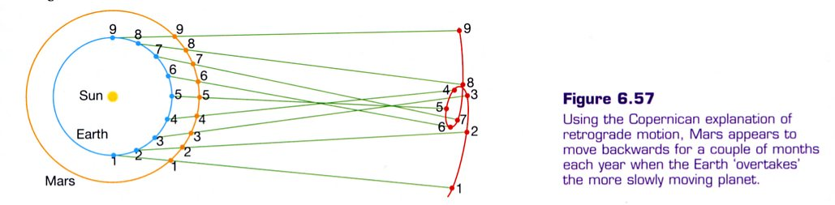

Kepler (1600) - formulated that planets orbit in ellipses with the Sun at one focus. He developed
three laws to describe planetary motion.

Kepler’s First Law states that the orbit of a planet is an ellipse with the Sun at one focus.

Kepler’s Second Law states that the radius from the Sun to a planet sweeps out equal areas in
equal times.

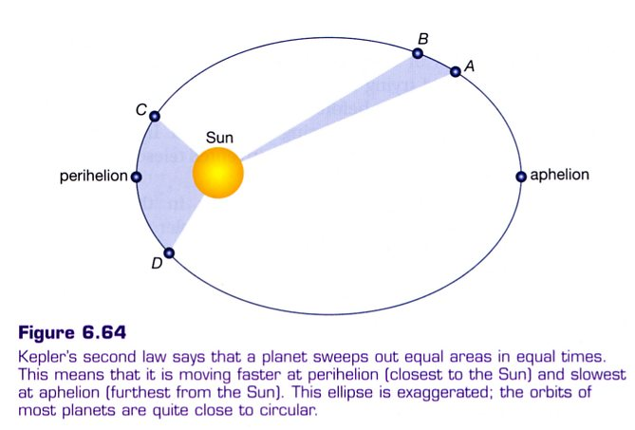

Kepler’s Third Law states that the square of the period of the planet (T²) is proportional to
the cube of the radius of the orbit (R³). That is:

where K is Kepler’s constant.

HUBBLE’S UNIVERSE

In the 1920's, Edwin Hubble was making detailed observations of galaxies. He found that when he looked at the spectrum of a galaxy, it was "red shifted". This means that it had the same pattern of lines as normal spectra but they were all moved towards the red (long wavelength) end of the spectrum.

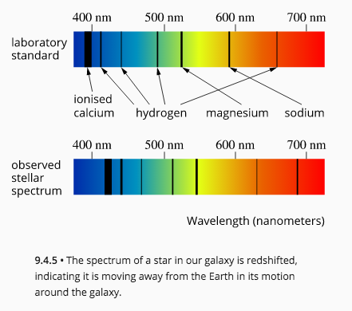

This was interpreted as the well-known ‘Doppler shift’ that occurs whenever a source of waves is moving towards or away from us.

The speed of the galaxy can be found from the amount of red shift.

where v_{galaxy} = the speed of the observed galaxy (ms^{–1}).
Δλ = the change in wavelength (m).
λ = the normal wavelength (m).
c = the speed of light (ms^{–1}).

Hubble measured the distance of the galaxies and found a remarkable pattern. The more distant
galaxies had greater red shifts, and the red shift was directly proportional to the distance of the galaxy.

i.e. The galaxies seemed to be speeding away from us, and those at the greater distances
were receding at greater speeds.

This became known as Hubble’s Law and is expressed as a simple equation.

where v_{galaxy} = the recession velocity of the galaxy (kms^{–1}).
H_{o} = Hubble’s constant (kms^{–1} Mpc^{–1}).
d = the distance of the galaxy (Mpc).

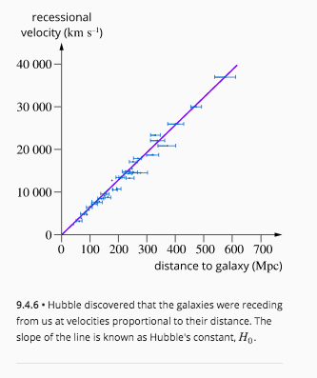
The value of Hubble’s constant is about 70 kms⁻¹ Mpc⁻¹.

It has proved difficult to find an accurate value for the constant because of the huge distances of the galaxies involved, but recent results from a satellite called WMAP (Wilkinson Microwave Anisotropy Probe) suggest a value of 71 kms⁻¹ Mpc⁻¹ to within 5%.

Not all galaxies are receding from us. Some of the closer ones are moving towards us (and so have blue shifts) owing to their gravitational interactions.

Example
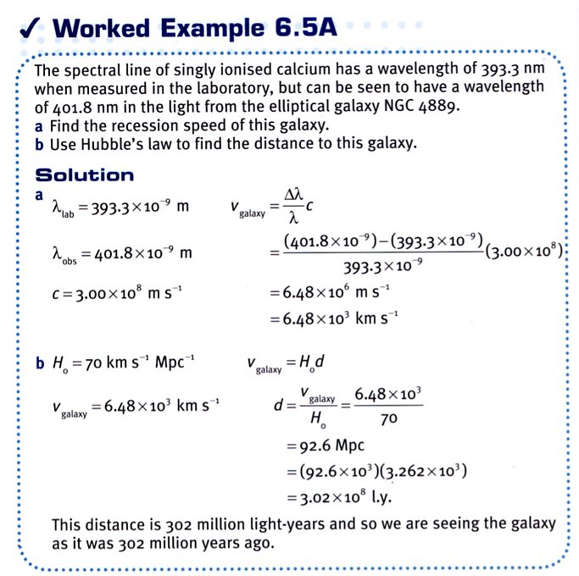

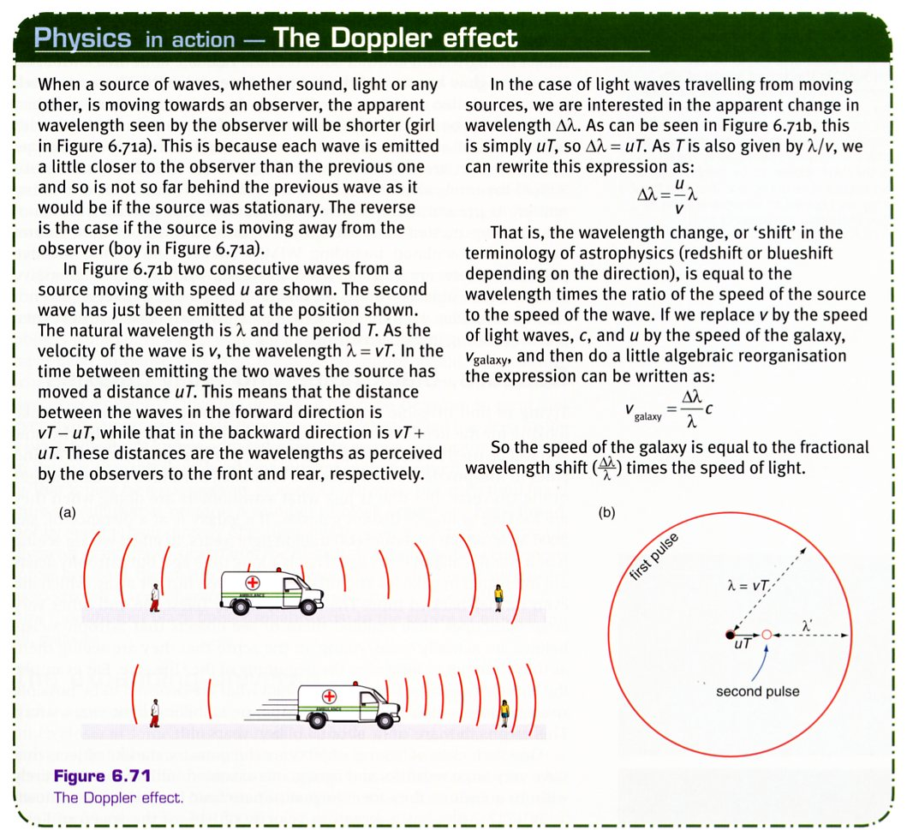
ORIGIN OF THE UNIVERSE

The Universe was thought to be infinite and unchanging in the time of Galileo and Newton.

Hubble realised that, because all the distant galaxies were receding from us, unless we just
happened to be in the ‘real’ centre of the Universe, the whole universe must be expanding and therefore the light from extremely distant stars will never reach us.

It is not the galaxies all moving away from one point in space - it is space itself that is expanding.

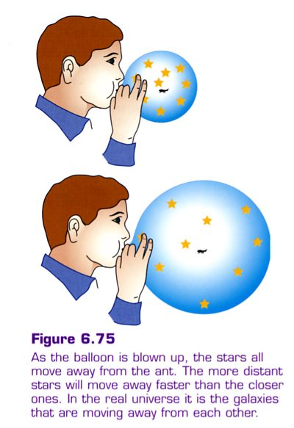
Analogy

Imagine an ant on a balloon that is being blown up. This balloon happens to have had little paper stars stuck onto it (not drawn on it). The ant would see all the paper stars moving away from it. Wherever the wanders on the balloon’s surface, it would see exactly the same thing.

The ant can travel in a "straight" line and end up back where it started if we held rigidly to what we believed was a straight course through space (and given more time than the lifetime of the Universe!) eventually end up back where we started.

i.e. The universe would appear "closed".

It is important to make the distinction between this expansion of space and a conventional explosion, in which everything flies out from one point in space.

To see uniform expansion in the explosion one would have to be right at the centre.

This is not the case for the expansion of the Universe (or the ant on the balloon). Astrophysicists talk of this as the cosmological principle. This states that the Universe is isotropic and
homogeneous - it will appear uniform in whatever direction one look and from wherever.

Did it all start with a big bang?

If space is expanding, then at some time in the past it must have been just a dot.

Not according to astronomer Fred Hoyle back in the 1950's. He put forward what became known as the Steady State Theory. His idea was that the Universe really was both infinite and expanding.

If it was infinite the expansion was not a problem, the ‘outer’ stars would never reach infinity and so could go on moving away from us forever. This would mean that the Universe was becoming "thinner" - less dense. Hoyle believes that matter is being created all the time at just the right rate to keep the density of the Universe constant.

His theory was disproved when cosmic microwave background radiation was discovered in the early 1960's by Arno Penzias and Robert Wilson.

The Big Bang Theory was not to be seen as an explosion from a small point in space - it was more correctly an explosion of spacetime. Einstein had already showed that time and space were not separate entities. So the big bang would not have occurred at some point in time any more than it would have occurred at a point in space. Time, space and matter were all created together.

(For more detail, Ch. 9.4 of the text.)

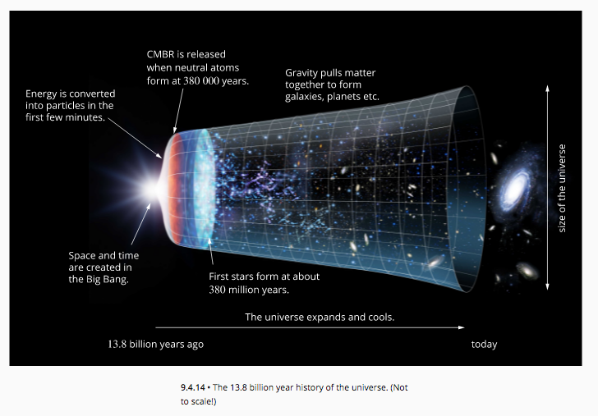

When was the bang?

If Hubble’s law is right, Physicists need to run the rate of expansion backwards to see when all the galaxies were in the same place.

Example

